A describe statement can be used to find out information about the content of an internal table. This includes the number of records the table holds, the reserve memory space used, and the type of table, if it's a standard table, sorted table, or a hash table.

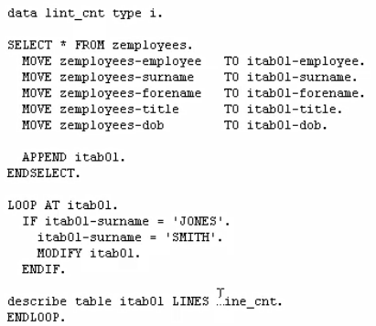

Then we want to know the number of records. So, what we do is use the addition of lines. Then we must tell the system how we want to store this value, so let's use a new variable called line_cnt.

So, this statement will return an integer value that represents the number of lines contained in our internal table, and the value will be stored in the variable we defined.



the insert statement allows us to insert records into any position we choose inside an internal table, by specifying the table index number. If we wanted to insert a record into an internal table. We declare the INSERT statement, internal table, we're going to insert record into. Then we specify the index number of the record that we want to insert our new record into. And this is where we can use our line_cnt which holds, in this case, the total number of records in our table.

